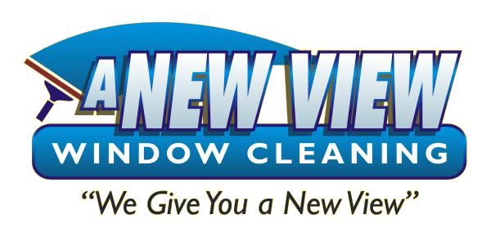 Wants to know…

You’re Not Selling That Property With Dirty Windows, Are You?

You know the scenario. You instruct your sellers to turn on the lights and open the blinds so the home will look bigger and brighter when it is shown. The problem is, the windows are dirty! They’re only dirty if you haven’t called A New View Window Cleaning.

But Why Should I Call?

Improve Curb Appeal and Saleability:
Cleaning windows is the best return on investment when preparing your home for sale. Clean windows mean a higher selling price according to Money Magazine (June 2003).

Money Magazine (March 1999) recommends exterior house washing as one of the top 4 ways to prepare a home for sale. According to the article you should:
Have the exterior of the house washed. Removing residue, dirt, and spider webs will vastly improve it’s appearance.

Have the entry pressure washed. Remove mold, algae, and other forms of unsightly grime from the entries and walkways.

To get these benefits - Visit www.anewviewia.com or
Call (319)325-9475 Now!

Services we offer are:
1 Window Cleaning (Traditional and Pure Water techniques)
2 Exterior House Washing (includes small decks, patios, and sidewalks)
3 Chandeliers and lighting fixture cleaning (including mirrors)
4 Gutter Cleaning (we can clean out debris, rinse and whiten gutter exteriors)
5 Screen Repair

Benefits of Choosing Our Services
1 Enhances curb appeal which increases the selling price.
2 Provides a healthier home by removing molds and mildew from exterior surfaces.
3 Everyone feels better looking through clean windows

