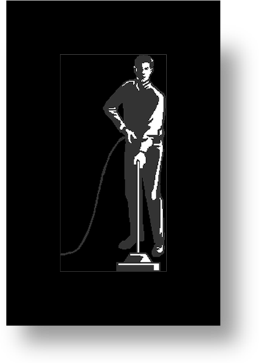
ABC CLEAN

Complete cleaning solutions for the homeowner

Abc Clean is your local family owned and operated cleaning services provider.
We specialise in:
- General Domestic Cleaning
- Post Party Cleaning
- Post Construction Cleaning

Our staff are uniformed, curteous and helpful.
Rubbish Bagging Window and mirror cleaning
Cobweb removal General dust, polish, vacuume clean.
Floors sweeping Skirtings, window and door sills dusting.
Carpet Vacuuming Picture frames cleaning.
Furniture Polishing. Light fittings and blinds dusting.

Special Kitchen Cleaning package available
Special Bathroom Cleaning package available

Call Robert directly on 087 123 5678

Call Rob directly for a competitive quote
on:
087 1272811

