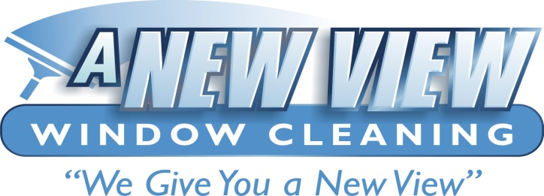 Damage Liability Waiver

This waiver, Dated this ________ day of ______, 20_____, is in effect as a blanket waiver for any and all jobs that Client has and or may hire Contractor to perform professional window cleaning methods and operations on.
This waiver is by & between A New View Window Cleaning , 325 E Madison St Washington, IA (Hereafter “Contractor”),
And: _______________________________________________ (Hereafter “Client”), and applies to all Owners, employees, and assigns of both Client and Contractor.
Client agrees to hold Contractor harmless in the event of damage caused by fabricating debris present on any heat-treated, heat strengthened, and or any tempered glass present on job site. Client agrees that Contractor is not responsible for detecting or finding fabricating debris. Client will agree to waive any liability of Contractor for any blemishes, marks, marring, etc., that may appear on said glass after standard and normal professional window cleaning methods are used in window glass cleaning procedures. Client agrees and understands that scrapers are considered a normal and accepted method for removal of post construction and other soils from window glass surfaces.
Client is entirely aware and understands that Contractor uses only professional grade tools, methods, and procedures for cleaning glass, and agrees that Contractor has been retained to provide such services. Client is aware and agrees that scrapers are one of the professional grade tools used in normal window glass cleaning procedures and methods.
Client is aware and agrees that Contractor has no control over quality of glass as it is manufactured, delivered, installed, fabricated, and assembled and has no control over the quality of finishing operations on cladding around glass, either wood or other material, on and or around glass. Client agrees that Contractor has no control over any other trades that may come into contact with said glass, and that Contractor will not be held liable for any damage, marks, blemishes, etc., that any other trade may have created on glass and or cladding, either wood or other type surfaces.
Client agrees to and understands that Contractor will only proceed with cleaning provided there is a waiver of liability signed by client.
Contractor will not be held liable for any damage to any heat-treated, heat strengthened, and or tempered glass. This waiver does NOT cover breakage due to negligence or mistreatment on the part of Contractor.
Agreed to and signed this ______ day of __________, 20___

_________________________ ___________________________

A New View Window Cleaning Client

